**Homework 1**

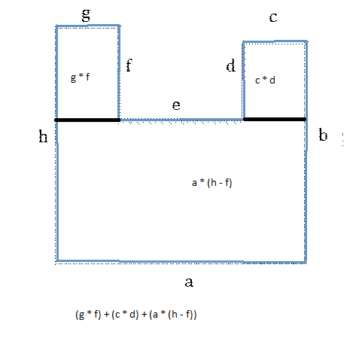

1. Separate base of the house into calculable pieces (as shown above)
2. Prompt user for the necessary wall lengths
   1. a, c, d, f, g, h
3. Prompt user for height of the walls
4. Calculate for the volume of the house
   1. (g * f) + (c * d) + (a * (h – f))
5. Print the volume for the user
6. Calculate the air tonnage
   1. ((g * f) + (c * d) + (a * (h – f))) / 1000
7. Print the tonnage for the user